**About us**

**Janet Healthcare was incorporated in the year 2007, with a declaration to provide the precisely wholesaling the products to clients. We are a Sole Proprietorship owned entity which is performing its occupational activities in a proficient manner in the field of wholesaling. The products spectrum we offer to our customers includes Patient Wheelchair, Patient Walker, hospital beds, Orthopedic Accessories, Digital Thermometer, adult diapers, nebulizer and many more.**

**We are well equipped dealers to offer a one-stop, hassle-free medicine and surgical solution. Our mission is to make best and widest range of surgical and healthcare products accessible for our customers. We keep our standard in offering the best quality, most innovative and cost-effective products. We are giving high priority to customer satisfaction, therefore we offer up to 60% of discount on our products.**

**We promise that we will deliver 100% genuine and quality products, deliver the products at the earliest for the benefit of our customers, to serve the best quality at affordable rates**

Our products

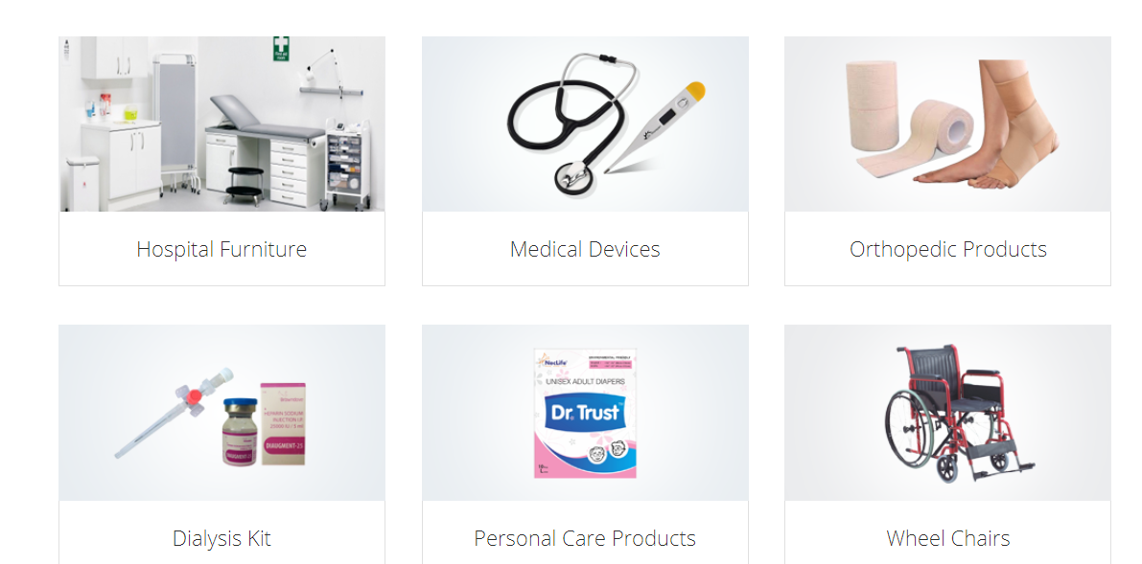

HISTORY OF JANET

Jane healthcare established in year 2007 is one of the leading wholesalers for surgical equipments and pharmacy in Kochi, Edappally.This well known establishment acts as a one stop solution for all the customers inside and outside Kochi.It’s quality driven organization offering a wide range of product for their customers. Over the course of its journey, this business has established a firm foothold in its industry. Janet healthcare strongly believes in customer satisfaction is as important as their product and services. This helped to establish a vast base of customers, which is growing day by day. The team is dedicated, responsible and put in lots of effort to achieve the goals and vision. Now they had expanded to a wide range of products and servicing offering with maximum discount to their customers.

**PRODUCTS AND SERVICES OFFERED**

Janet healthcare deals with a wide range of products to satisfy the requirements of their customers. The staffs at this establishment are courteous and prompt at providing any assistance. The product range includes wheelchair, hospital beds, surgical equipments ,blood sugar monitor,blood pressure monitor,nebulizer,adult diapers,women care , babycare products, cosmetics, petcare products. Customers can avail all the products at maximum discount. Payment for purchases is very easy using any mode of payment such as cash/card.

Heading:we are dedicated to serve you



**OUR NEW VENTURE**

JANET HEALTHCARE PHARMACY & SURGICALS,EDAPALLY

Janet healthcare edapally is our first venture ie a pharmacy cum, surgical supermarket.It also includes medicines, surgical equipments, babycare products, cosmetics, petcare products.With over 10years of experience In wholesale field ,we put our next footstep as retail dealers. This outlet is well stocked with genuine health products and medicines ie one stop solution for all your medical needs.

Customers can avail maximum discounts and get best quality products.We offer 13% discount on medicines,18% discount on insulin and upto 60% discount on surgical items .More than this we have special offer prices for products such as blood sugar monitoring ,adult diapers etc.

We provide medicines at your doorstep with the comfort of home delivery. All the products we distribute comply with the Drugs and Cosmetics Act 1945, as well as any other applicable rules or amendments. We assure you that all of these products will meet your high standards, now and in the future.

Our products

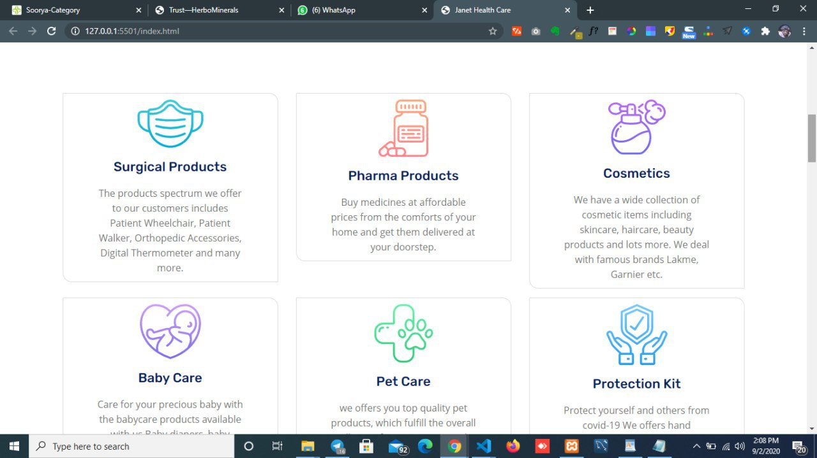

**OTHER BRANCHES**

DOCTORS SURGICALS

Doctors surgical in kolenchery is one of the leading supplier in wheel chair,. They also deal with weighing machine, surgical items, hospital beds and much more. In Ernakulum the establishment occupies a [prominent location in kolenchery.It is at MM junction, near IOC pump which makes it easy for first time visitors to reach us. Customers can avail all the products at maximum discount. Payment for purchases is very easy using any mode of payment such as cash/card. Working time will be 10am-8pm from Monday to Saturday

1st floor,varappathukuzhy Building

M M JN kolenchery

Email: [doctors_surgicals@yahoo.com](mailto:doctors_surgicals@yahoo.com)

Ph:0484-2763666 Mob:9072333716,9745940885

COMFORT SURGICALS

Comfort surgical, Thalassery is one of the leading business dealers in medical equipment category. They have wide range of products to satisfy the customer requirements .The products include medical equipments, nebulizer, elbow and wrist support belts, wheel chair and many more. It is at NH Kannur-thalassery road, opposite to cooperative hospital which makes it easy for visitors to reach us. Customers can avail all the products at maximum discount. Payment for purchases is very easy using any mode of payment such as cash/card. Working time will be 9.30am-8:30pm from Monday to Saturday

1st floor,pearlview plaza

Venus corner,opp cooperative hosp

Thalassery

Ph:04902327522

9946233778

**TEAM JANET**

**Owners**

**Mr Baiju**

**Mr satheesh**

**COMPANIES WE DEAL WITH**